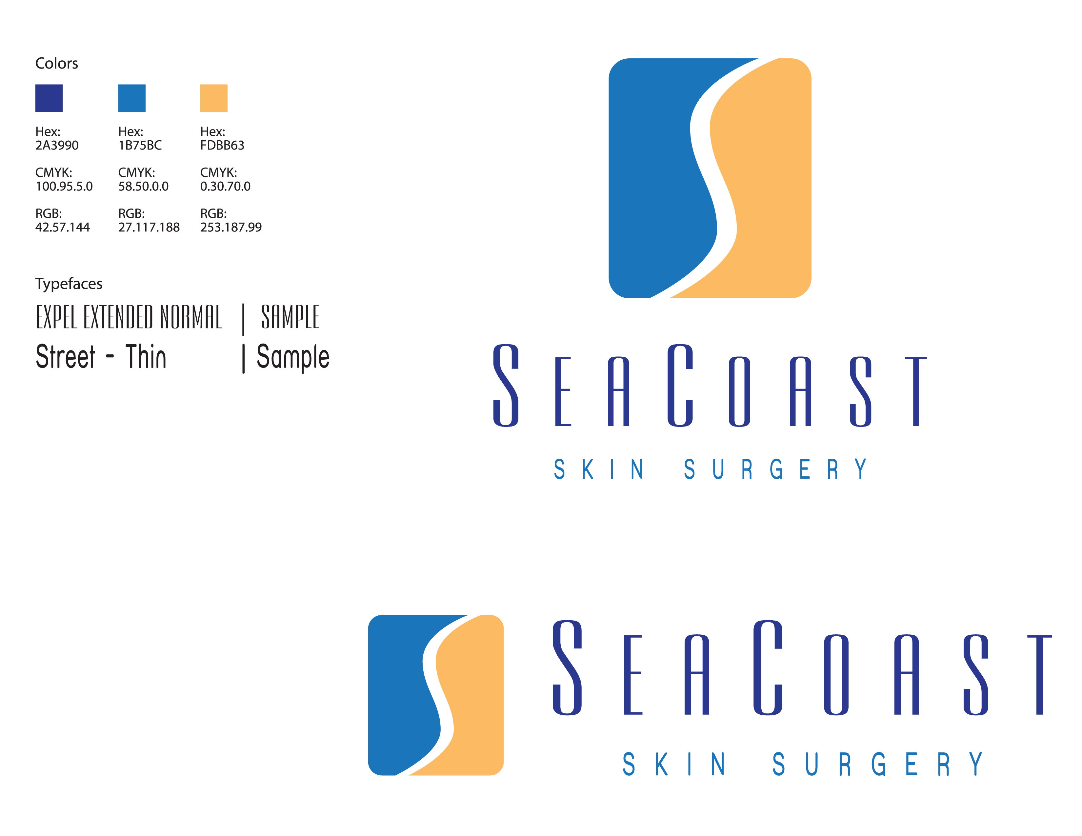

Phone: 910-256-2100
Fax: 910-256-7999

Post CO2 Laser/ED&C Wound Care Instructions

Procedure:
1. Keep original bandage on the site(s) ideally for 24 hours. It is preferable to keep the area(s) dry during this period. Once you begin showering, leave the dressing on in the shower while allowing it to get wet.

2. Immediately following your shower, remove the wet bandage and cleanse the area with a mild liquid soap and water solution (Soft soap, Dial, etc) being certain to remove all old ointment/drainage from the surface.

3. Rinse and dry the area with a clean Q-tip or gauze pad.

4. Apply a thin layer of Vaseline, A&D ointment, or Polysporin to the wound. (Do not use Neosporin)

5. Reapply a small airtight dressing over the wound. It’s very important to keep the area moist with ointment and sealed on all sides. Your surgical site will heal faster and have a better cosmetic appearance if you do not allow air to get to it.

6. Repeat this procedure every 24 hours until the area is healed. This usually takes 10-14 days.

What to Expect:
1. You can expect some mild discomfort. This is highly variable among patients, and is also dependent upon the location. Some areas are more sensitive than others. You may take an over the counter pain reliever as needed.

2. You should expect mild swelling, redness, and bruising around the site. This will resolve in a few days.

3. Bleeding is rare, but if it does occur, sit or lie down and apply firm constant pressure to the wound for 20 minutes. If the bleeding has not stopped, repeat for 20 additional minutes. If it persists, call our office or Dr. Viehman after hours.

4. Once the wound has completely healed over, begin using sunscreen to prevent darkening of the scar.

Any further questions can be addressed through our office at 910-256-2100.
Normal Business Hours: Monday, Tuesday, Thursday 7:30am-5:00pm, and Wednesday and Friday 7:30- 1:00pm.

